【Product Picture】

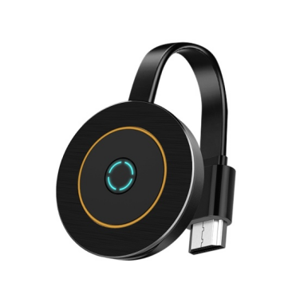

**【Product Description】**

The DD546 ScreenCast is a portable wireless display device that supports 4K Ultra HD screen mirroring. Equipped with an HDMI 1.4 interface and dual-band WiFi technology, it is compatible with televisions, monitors, projectors, and other display devices. It allows seamless mirroring from Apple and Android smartphones, as well as personal computers, with a single click. The system also features built-in DLNA streaming and online upgrade capabilities, providing an efficient and stable wireless audio-visual transmission experience.

**【Tech Specs】**

|  |  |
| --- | --- |
| **Technical Specification** | **Description** |
| Model | DD546 |
| Color | Black |
| Connector Type | HDMI, Micro usb |
| HDMI Version | HDMI 1.4 |
| Supported Resolution | 1920×1080@60Hz (Compatible with 1280×720, 1280×800, etc.) |
| Wireless Standard | Dual-band WiFi (2.4G+5G, 802.11 a/b/g/n/ac) |
| Transmission Distance | Up to 5 meters in open space |
| System Compatibility | Windows , macOS, Android |
| Plug and Play | Windows systems require software downloads |
| Power Input | USB Power: 5V/2A |
| Material | ABS |
| Cable Length | 58×58×10mm |
| Weights | 28g |

**【Features】**

1. **HD Quality:** Supports 1080p resolution .elivering clear picture details and accurate color reproduction.
2. **Cross-Platform Compatibility:** Seamlessly connects with Apple AirPlay, Android Miracast, and Windows wireless projection without the need to switch modes.
3. **Dual-Band WiFi for Stability:** Automatically switches between 2.4G and 5G bands to adapt to complex network environments, ensuring smoother transmission.
4. **Online Upgrade Capability:** Supports firmware online upgrades to continuously optimize device performance and compatibility.

**【Application Environment】**

1. **Business Presentations:** Enhance flexibility in presentations by wirelessly mirroring content, reducing the clutter of cables.
2. **Home Entertainment:** Wirelessly transmit videos from smartphones, tablets, or computers to TVs or projectors, creating a home theater experience.
3. **Educational Training:** Facilitate convenient wireless teaching projections in classrooms or meeting rooms.
4. **Remote Work:** Suitable for mobile office and remote meetings, providing efficient presentation and communication methods.
5. **Creative Design:** Ideal for design reviews and client presentations, ensuring high-definition display of visuals.

**【Important Notice】**

1. **Compatibility Check:** Ensure that your device supports the necessary protocols (AirPlay, Miracast) for wireless transmission.
2. **Power Supply:** Use the provided 5V/2A power adapter to ensure stable operation.
3. **Network Environment:** For optimal performance, use in an environment with minimal WiFi interference.
4. **Safety Precautions:** Avoid exposing the device to extreme temperatures or moisture to prevent damage.