【Product Picture】

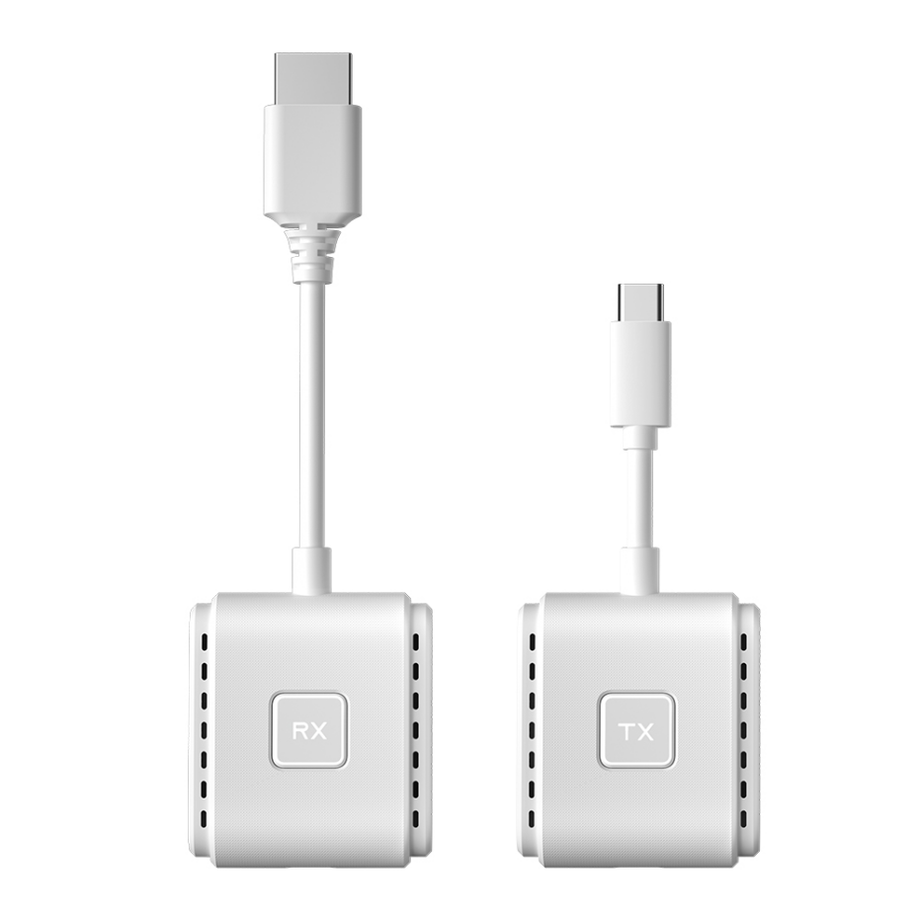

**【Product Description】**

The DD545-TC Wireless Transmission System is a high-definition wireless screen mirroring device based on dual-band WiFi (2.4G+5G). It supports plug-and-play functionality without the need for complex setup. By connecting quickly via the USB-C interface, it allows you to wirelessly mirror content from smartphones, tablets, laptops, and other devices to TVs, projectors, or monitors, delivering 1080P@60Hz high-definition visuals with low-latency transmission. It is ideal for home entertainment, business meetings, online education, and other scenarios.

**【Tech Specs】**

|  |  |
| --- | --- |
| **Technical Specification** | **Description** |
| Model | DD545-TC |
| Color | White , Black |
| Connector Type | Transmitter: USB-C ×2 (Video Input + 60W Fast Charging); Receiver: HDMI, USB-C |
| HDMI Version | HDMI 1.4 |
| Supported Resolution | 1920×1080@60Hz (Compatible with 1280×720, 1280×800, etc.) |
| Wireless Standard | Dual-band WiFi (2.4G+5G, 802.11 a/b/g/n/ac) |
| Maximum Transmission Distance | Up to 50 meters in open space |
| Modes Supported | Replication and extension modes for HDMI |
| Latency | 80-100ms (in open space) |
| Video Encoding Formats | H.264 |
| Audio Support | Synchronous transmission of high-definition audio |
| System Compatibility | Windows , macOS, Android, |
| Plug and Play | YES |
| Power Input | USB Power: 5V/2A (Transmitter and Receiver) |
| Max Power Consumption | 3W |
| Transmitter Features | 60W fast charging (device support required) |
| Material | ABS |
| Operating Temperature | 0℃ to 50℃ |
| Cable Length | 49.6×43.6×16.6mm |

**【Features】**

1. **Dual-Band WiFi, Stable Transmission：**Automatically switches between 2.4G and 5G bands, with strong wall-penetration and stable signal transmission.
2. **One-Click Screen Mirroring, Easy to Use：**Plug-and-play functionality with no driver installation needed. Connect smartphones and computers in just 5 seconds.
3. **High-Definition Visuals, Low Latency：**Supports 1080P ultra-clear resolution with latency as low as 80ms, ensuring smooth game and movie streaming.
4. **Simultaneous Screen Mirroring and Fast Charging**：The transmitter supports 60W fast charging, efficiently charging devices while casting content.
5. **Multi-Device Compatibility：**Compatible with smartphones, tablets, and laptops, supporting Windows, Android, and Apple systems.

**【Application Environment】**

1. **Home Theater:** Wirelessly cast movies from your phone or tablet to enjoy a larger screen experience.
2. **Office Meetings:** Wirelessly mirror your laptop screen for smooth PPT presentations without delay.
3. **Online Classes:** Instantly project tablet course materials, making teaching and interaction more visual.
4. **E-sports Gaming:** Low-latency screen mirroring provides a better big-screen gaming experience.

**【Important Notice】**

1. **Function Limitations:** The device's wireless transmission performance may be affected by a large number of wireless devices in the surrounding environment. Try to avoid using it in areas with intense wireless signal interference.​
2. **Device Maintenance:** Regularly clean the interfaces of the transmitter and receiver with a dry, lint-free cloth to ensure good contact and stable signal transmission.​
3. **Safe Operation:** Do not disassemble the device by yourself. If there is a malfunction, contact the official customer service for professional repair to avoid safety hazards.​
4. **Data Security:** When using the device in public places, be aware of potential data security risks. Avoid transmitting sensitive information to prevent information leakage.