【Product Picture】

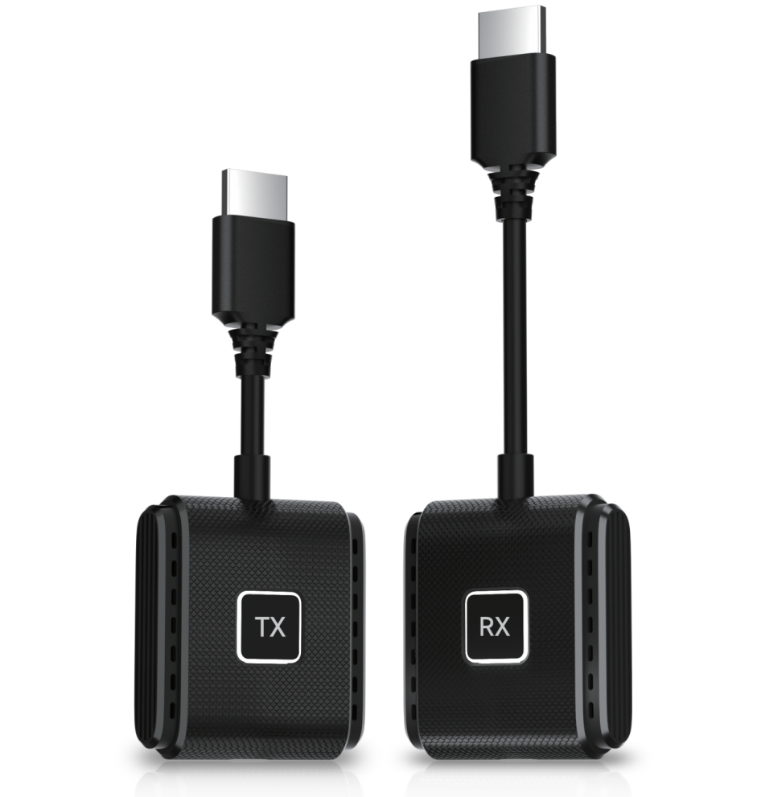

**【Product Description】**

The DD545-TH Wireless Transmission System is a high-definition wireless screen mirroring device based on dual-band WiFi (2.4G+5G). It supports plug-and-play functionality without the need for complex setup. By connecting quickly via the HDMI interface, it allows you to wirelessly mirror content from smartphones, tablets, laptops, and other devices to TVs, projectors, or monitors, delivering 1080P@60Hz high-definition visuals with low-latency transmission. It is ideal for home entertainment, business meetings, online education, and other scenarios.

**【Tech Specs】**

|  |  |
| --- | --- |
| **Technical Specification** | **Description** |
| Model | DD545-TH |
| Color | White , Black |
| Connector Type | Transmitter: HDMI, USB-C  Receiver: HDMI, USB-C |
| HDMI Version | HDMI 1.4 |
| Supported Resolution | 1920×1080@60Hz (Compatible with 1280×720, 1280×800, etc.) |
| Wireless Standard | Dual-band WiFi (2.4G+5G, 802.11 a/b/g/n/ac) |
| Maximum Transmission Distance | Up to 50 meters in open space |
| Modes Supported | Replication and extension modes for HDMI |
| Latency | 80-100ms (in open space) |
| Video Encoding Formats | H.264 |
| Audio Support | Synchronous transmission of high-definition audio |
| System Compatibility | Windows , macOS, Android, |
| Plug and Play | YES |
| Power Input | USB Power: 5V/2A (Transmitter and Receiver) |
| Max Power Consumption | 3W |
| Material | ABS |
| Operating Temperature | 0℃ to 50℃ |
| Cable Length | 49.6×43.6×16.6mm |

**【Features】**

1. **Dual-Band WiFi, Stable Transmission：**Automatically switches between 2.4G and 5G bands, with strong wall-penetration and stable signal transmission.
2. **One-Click Screen Mirroring, Easy to Use：**Plug-and-play functionality with no driver installation needed. Connect smartphones and computers in just 5 seconds.
3. **High-Definition Visuals, Low Latency：**Supports 1080P ultra-clear resolution with latency as low as 80ms, ensuring smooth game and movie streaming.
4. **Multi-Device Compatibility：**Compatible with smartphones, tablets, and laptops, supporting Windows, Android, and Apple systems.

**【Application Environment】**

1. **Home Theater:** Wirelessly cast movies from your phone or tablet to enjoy a larger screen experience.
2. **Office Meetings:** Wirelessly mirror your laptop screen for smooth PPT presentations without delay.
3. **Online Classes:** Instantly project tablet course materials, making teaching and interaction more visual.
4. **E-sports Gaming:** Low-latency screen mirroring provides a better big-screen gaming experience.

**【Important Notice】**

1. **Function Limitations:** The device's wireless transmission performance may be affected by a large number of wireless devices in the surrounding environment. Try to avoid using it in areas with intense wireless signal interference.​
2. **Device Maintenance:** Regularly clean the interfaces of the transmitter and receiver with a dry, lint-free cloth to ensure good contact and stable signal transmission.​
3. **Safe Operation:** Do not disassemble the device by yourself. If there is a malfunction, contact the official customer service for professional repair to avoid safety hazards.​
4. **Data Security:** When using the device in public places, be aware of potential data security risks. Avoid transmitting sensitive information to prevent information leakage.